JECRC
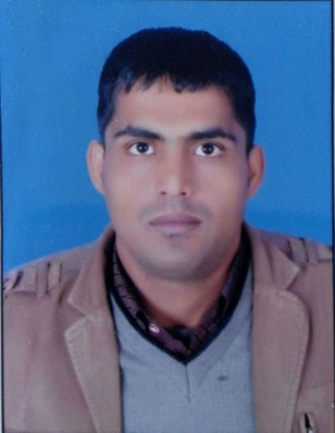Affix and Attest
passport
size photograph
JAIPUR

INDIVIDUAL Lab Instructor DATA SHEET
Name of the Lab Instructor | : | Prem Chand Sharma
Present Designation | : | Lab Instructor
Email Id: premchand.ee@jecrc.ac.in premchand.sharma7@gmail.com
Contact Details: +919929210079

I. Particulars of Educational Qualification: (only completed)

Category | Name of the Degree | Specialization | Year of Passing | Name of the College | Name of the University
UG | Bachelor of Arts | Arts | 2011 | VMOU | VMOU
PG | Pursuing PGDCA | Computer |  | JNU | JNU

II. Academic Experience : 10 Year

III. Industrial Experience :

IV. Awards/Achievements :

VI. Research/Specialization :

VII. Course Taught :

